**Business Requirements Document for The Students Pocket**

**Register Functionally**

1. Student can register with the details as follows:

First Name: Test

Last Name: Test

Student ID: G00000000

Pin: 123456

1. Register Button cannot be presses unless all form fields are filled in.
   1. User in redirected to /login

**Login**

1. Student with ID G00000000 and pin 123456 can login to the application and is redirected to/home.
   1. Message is displayed if user entered the wrong information

Not the correct information

**CRUD Functionally (CREATE, READ, UPDATE, DELETE)**

1. Student can add a new module to his/her records in the databases.

5.0 Student can view their modules entered in the Module overview page.

6.0 Student can edit a module record when they click the edit button.

7.0 Student can delete a module from their records by pressing the delete button.

View of Register page as describe above.

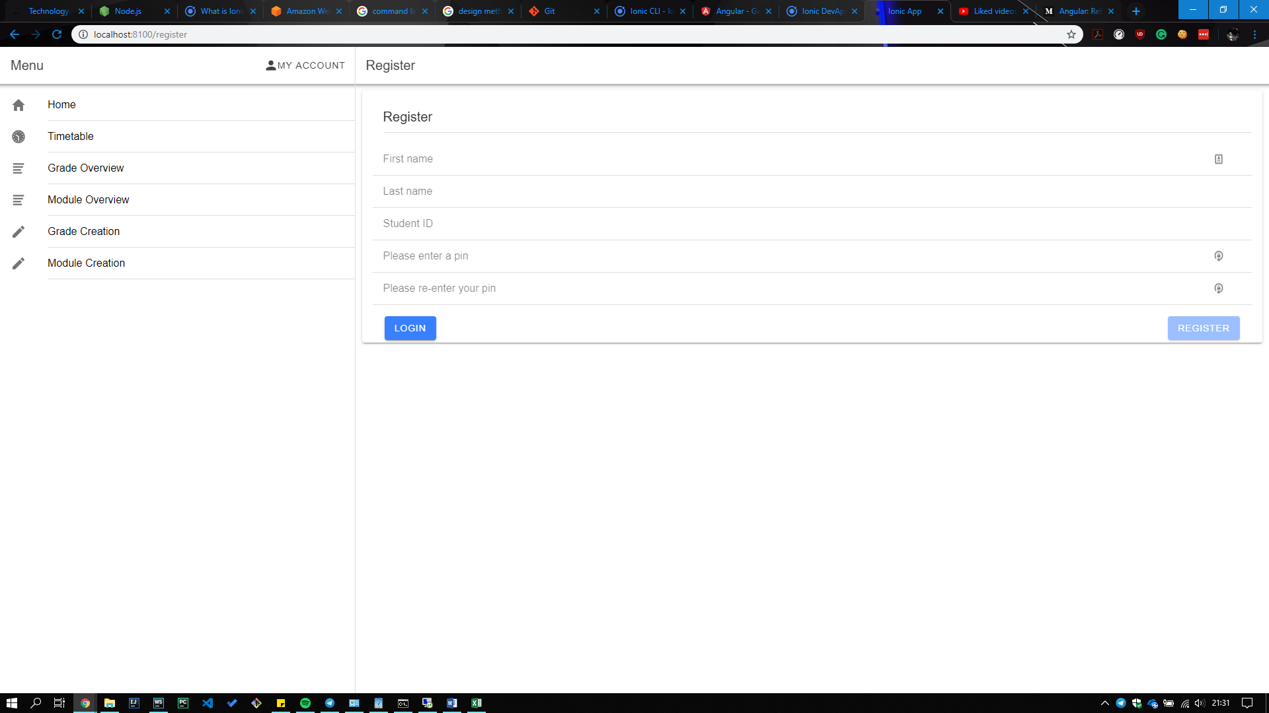

View of Login page as describe above:

